To assess the effectiveness of the proposed inverter, computer simulations were carried out in the MATLAB/Simulink environment [35]. The inverter was tested under input supply voltage of 75 V, as designed for a 250 W. This testing revealed peak-peak voltage (V₀), load current (I₀), and inductor current (i_{L}) are illustrated in Fig. 4 respectively. The peak output voltage value stands at 75V, with a peak load current of approximately 6.3 A. The inductor current reaches a peak value of about 6 A. The converter's performance hinges on the voltage and current stress experienced by the power switches. In this regard, the voltage across and current through the IGBTs (S₁, S₃) and (T₁-T₄) of the converter are depicted in Fig. 5(a)-(f), respectively. When a switch is OFF, the current through it and the voltage across it are ideally zero and at its peak when it's ON, respectively. The maximum voltage stress magnitude equals the supply voltage (i.e., 75 V). The frequency spectrum of the output voltage and Total Harmonic Distortion are depicted in Fig. 6. The THD percentage is observed to be approximately 4.99% without the utilization of a filter across the load. The proposed inverter also operates in bidirectional mode, where the load acts as the input and the input source acts as the load as shown in Fig. 7. In this case input source consider as peak voltage of 75V and power rating is considered as 250W.

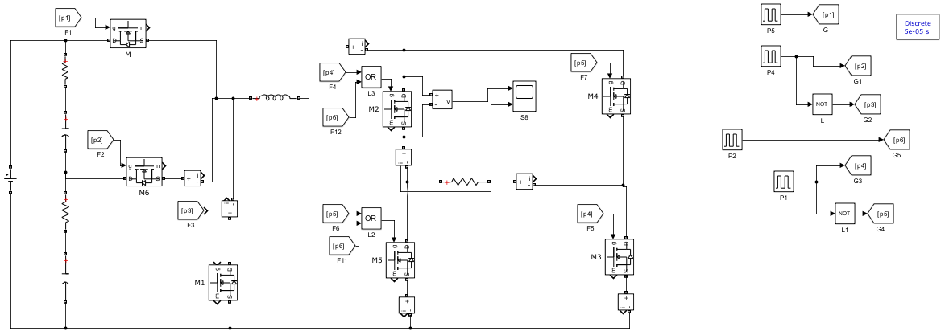

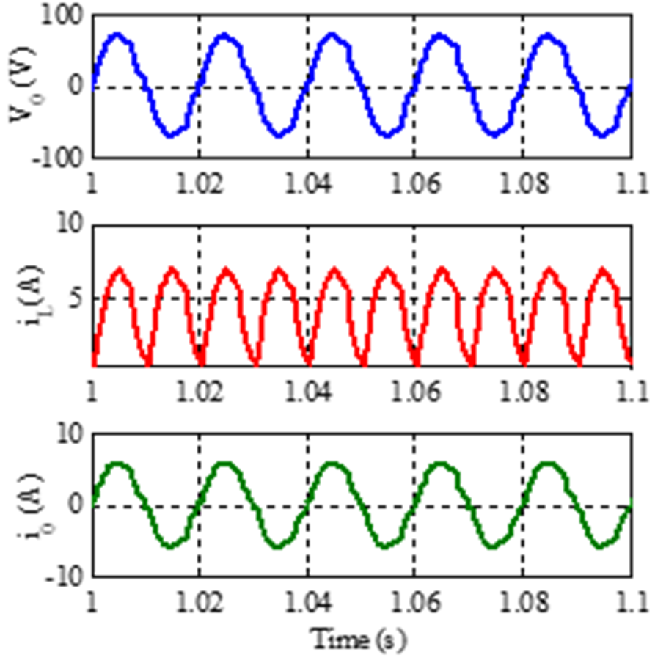
Fig. 4. Simulation results in DC-AC mode: Output voltage (V₀), Load current (I₀), and Inductor current (I_{L})
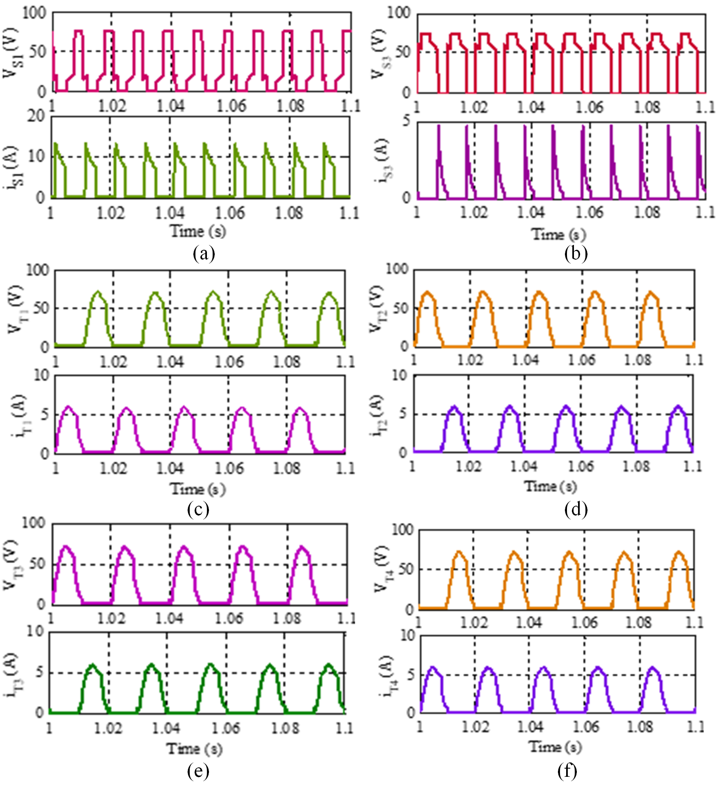
Fig. 5. Semiconductor stress: (a) S₁, (b) S₃, (c) T₁, (d) T₂, (e) T₃, (f) T₄
Fig. 6. FFT analysis
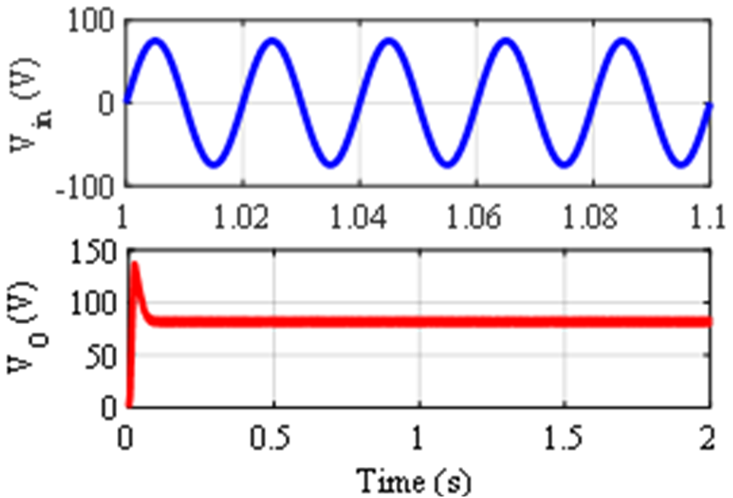
Fig. 7. Simulation results in bidirectional mode: Input voltage (V_{in}) and output voltage (V_{O}).

